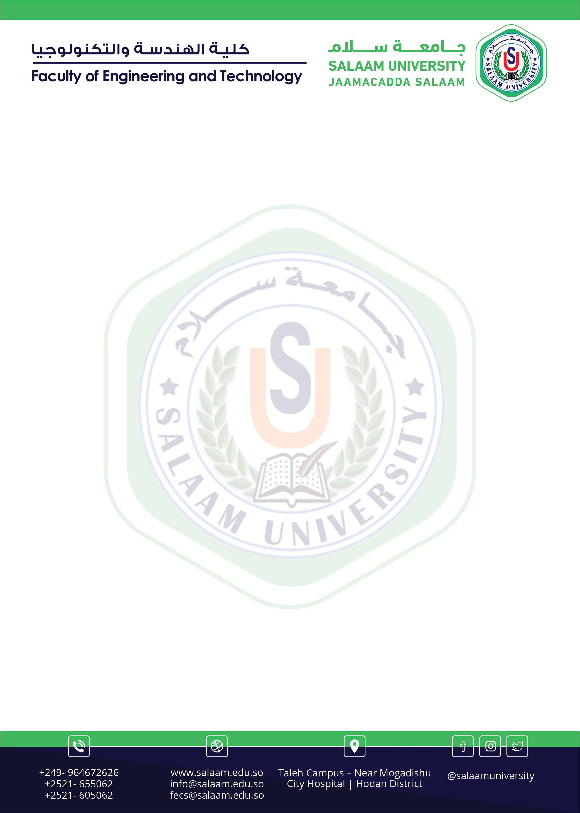

Salaam University
Faculty of Computer Science and Technology

Thesis Group

No | Group name | Id | Topic Name | Sup. name
 | Yusuf Ridwaan C/kariin | 8437 | Certificate date of birth | Eng:Ismail Abdullahi Ahmed
 | C/risaaq Ali Mohamud | 9573 | Certificate date of birth | Eng:Ismail Abdullahi Ahmed
 | Hanad Ahmed Mohamud | 9190 | Certificate date of birth | Eng:Ismail Abdullahi Ahmed
 | Mahamed Liibaan Daahir | 9025 | Certificate date of birth | Eng:Ismail Abdullahi Ahmed
 | Ismaciil Mohamed Hintir | 8968 | Certificate date of birth | Eng:Ismail Abdullahi Ahmed
 | C/raxmaan Nuur Shidane | 8724 | Certificate date of birth | Eng:Ismail Abdullahi Ahmed

Prepared by: Ismail Abdullahi Ahmed
Date: _____________________________

